Task 1:

Output:
Number of observations: 7264388.0
m = 2.37 b = 8.99
Run time: 51 minutes

Spark History:
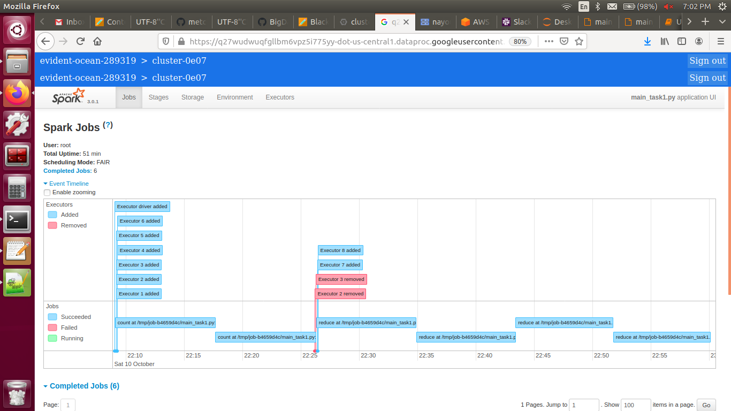
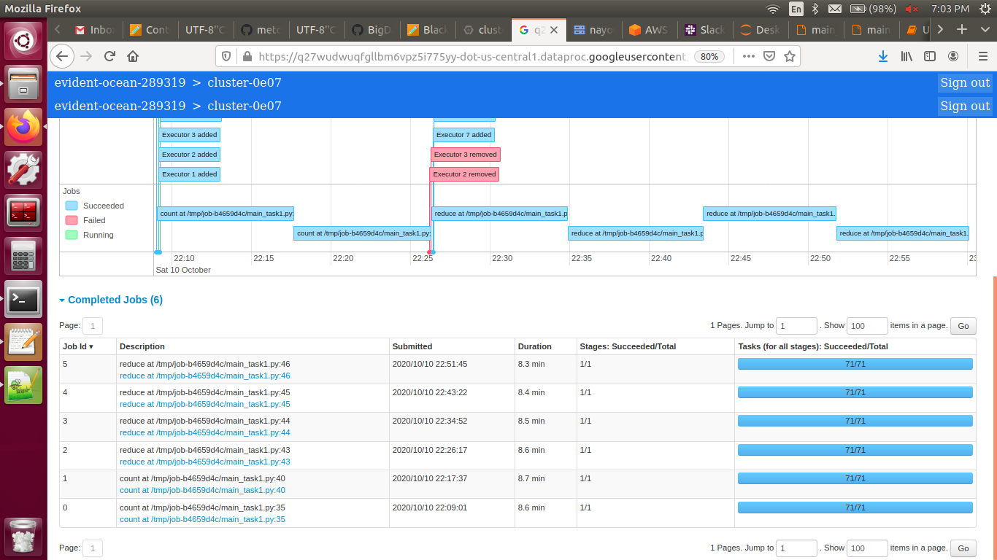

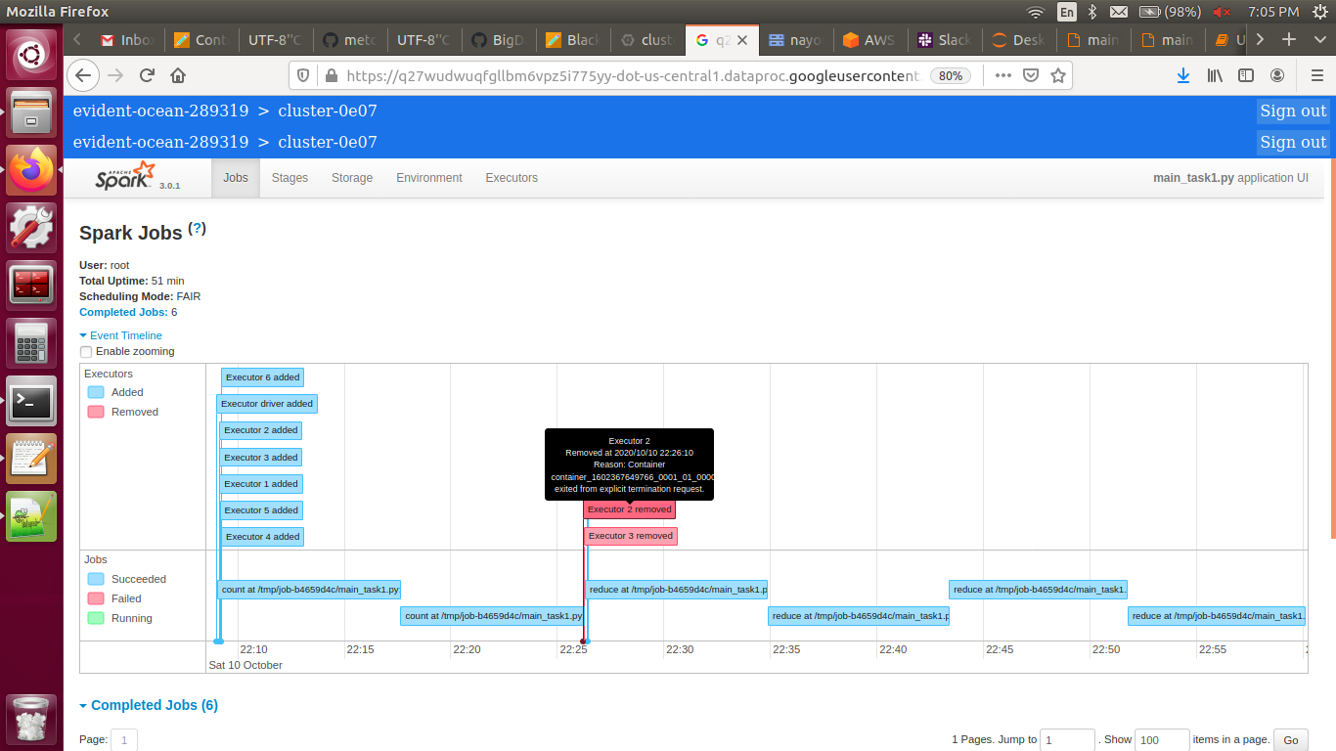

Task 2:

Output:
Number of observations: 7264388.0
Iteration = 0 Cost = 1525.9444270020842 lr = 0.001 m = 1.11 b = 0.17
Iteration = 1 Cost = 683.3579139119183 lr = 0.0010500000000000002 m = 1.8 b = 0.22
Iteration = 2 Cost = 312.0419282043817 lr = 0.0011025000000000002 m = 2.25 b = 0.26
Iteration = 3 Cost = 157.151337662887 lr = 0.0011576250000000002 m = 2.55 b = 0.28
Iteration = 4 Cost = 96.25910654822792 lr = 0.0012155062500000004 m = 2.74 b = 0.3
Iteration = 5 Cost = 73.80660035923026 lr = 0.0012762815625000006 m = 2.85 b = 0.31
Iteration = 6 Cost = 66.08202938385433 lr = 0.0013400956406250007 m = 2.91 b = 0.32
Iteration = 7 Cost = 63.61518992543366 lr = 0.0014071004226562508 m = 2.95 b = 0.32
Iteration = 8 Cost = 62.88624570948372 lr = 0.0014774554437890634 m = 2.97 b = 0.33
Iteration = 9 Cost = 62.68532852405242 lr = 0.0015513282159785166 m = 2.98 b = 0.33
Cost stopped decreasing at: 10
Run time: 18 minutes

Spark History:

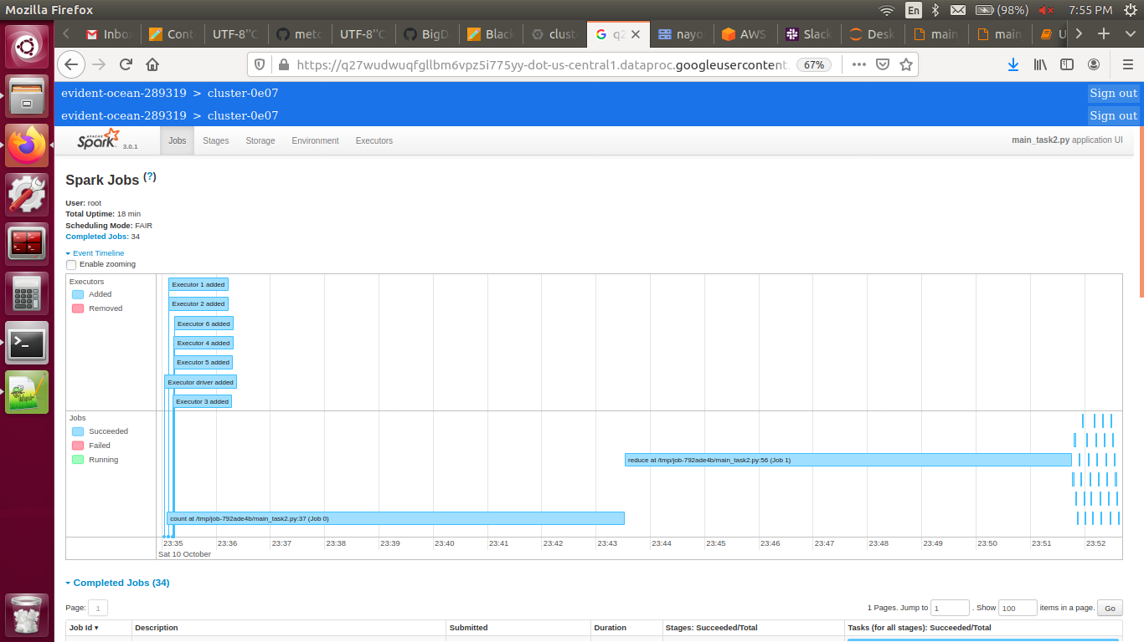

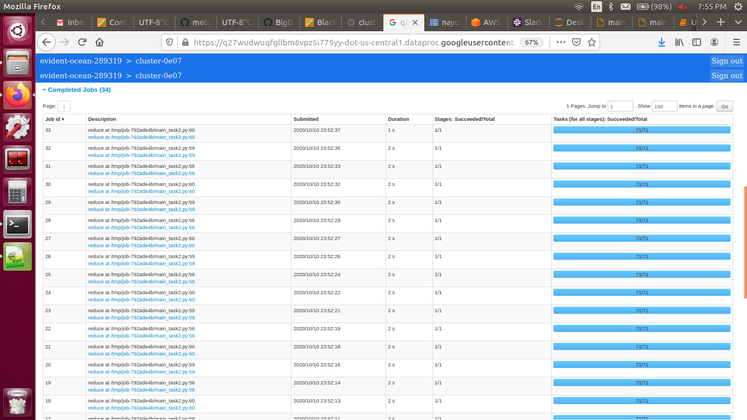
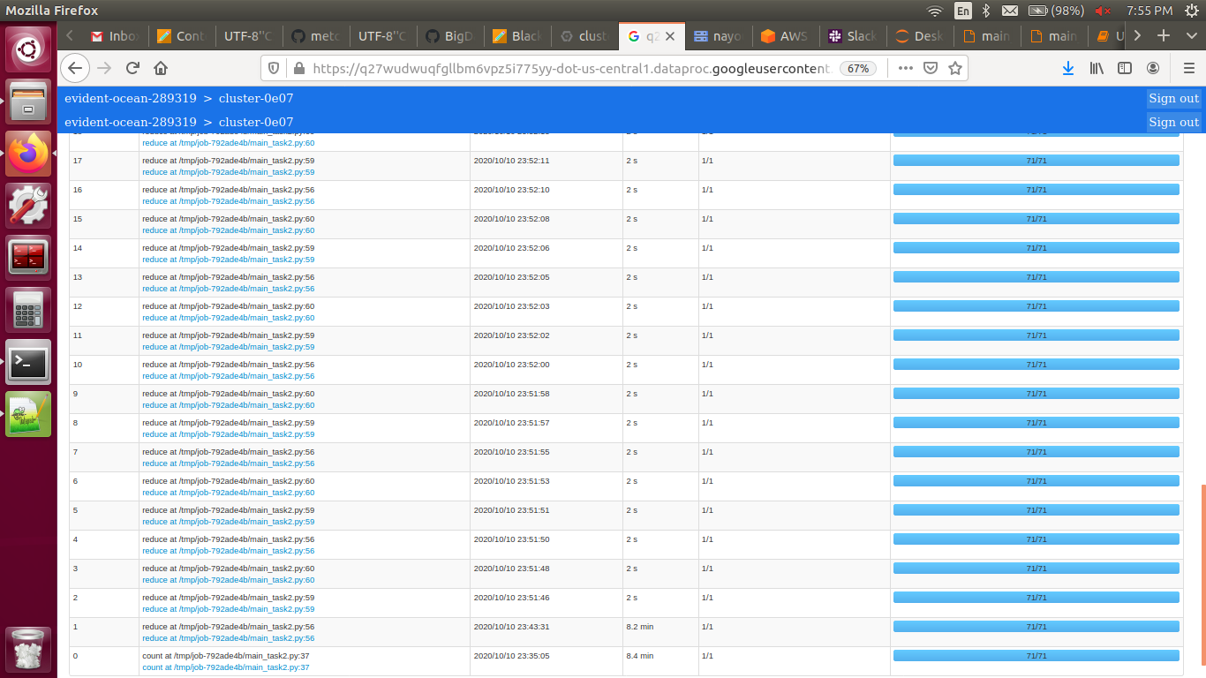

Task 3:

Output:
Number of observations: 7264388.0
Iteration = 0 Cost = 1899.1891549307134 lr = 0.001 theta = [0.18 2.7 1.21 3.6 0.11]
Iteration = 1 Cost = 37235.50528179434 lr = 0.0005 theta = [ 0. -3.31 -1.28 -4.14 0.08]
Iteration = 2 Cost = 113537.85511861234 lr = 0.00025 theta = [0.16 1.9 0.9 2.65 0.11]
Iteration = 3 Cost = 15882.493025146012 lr = 0.00026250000000000004 theta = [ 0.1 -0.16 0.04 0. 0.1 ]
Iteration = 4 Cost = 3144.0919381116914 lr = 0.00027562500000000005 theta = [0.13 0.78 0.44 1.24 0.11]
Iteration = 5 Cost = 865.9901000484731 lr = 0.00028940625000000006 theta = [0.11 0.25 0.23 0.59 0.1 ]
Iteration = 6 Cost = 331.1404773839557 lr = 0.0003038765625000001 theta = [0.12 0.56 0.36 1.01 0.11]
Iteration = 7 Cost = 172.84644736555924 lr = 0.00031907039062500014 theta = [0.12 0.32 0.27 0.73 0.1 ]
Iteration = 8 Cost = 116.53064204080583 lr = 0.00033502391015625017 theta = [0.12 0.48 0.34 0.97 0.11]
Iteration = 9 Cost = 94.31637380320298 lr = 0.0003517751056640627 theta = [0.12 0.31 0.28 0.78 0.11]
Iteration = 10 Cost = 86.71701655321834 lr = 0.00036936386094726584 theta = [0.12 0.45 0.34 0.99 0.11]
Iteration = 11 Cost = 88.45664735362443 lr = 0.00018468193047363292 theta = [0.12 0.36 0.31 0.9 0.11]
Iteration = 12 Cost = 40.850883610874945 lr = 0.00019391602699731457 theta = [0.12 0.36 0.31 0.9 0.11]
Iteration = 13 Cost = 40.41348524270515 lr = 0.00020361182834718032 theta = [0.12 0.35 0.31 0.91 0.11]
Iteration = 14 Cost = 39.983475530765304 lr = 0.00021379241976453935 theta = [0.12 0.34 0.31 0.91 0.11]
Iteration = 15 Cost = 39.55174416003262 lr = 0.0002244820407527663 theta = [0.12 0.33 0.31 0.92 0.11]
Iteration = 16 Cost = 39.119203770824726 lr = 0.00023570614279040463 theta = [0.12 0.33 0.31 0.93 0.11]
Iteration = 17 Cost = 38.68685991003641 lr = 0.0002474914499299249 theta = [0.12 0.32 0.31 0.93 0.11]
Iteration = 18 Cost = 38.255765665842084 lr = 0.00025986602242642116 theta = [0.12 0.31 0.31 0.94 0.11]
Iteration = 19 Cost = 37.82701513073348 lr = 0.0002728593235477422 theta = [0.12 0.3 0.31 0.95 0.11]
Iteration = 20 Cost = 37.40173622446669 lr = 0.00028650228972512936 theta = [0.12 0.29 0.31 0.95 0.11]
Iteration = 21 Cost = 36.98108235930382 lr = 0.00030082740421138586 theta = [0.12 0.28 0.3 0.96 0.11]
Iteration = 22 Cost = 36.56622293999419 lr = 0.0003158687744219552 theta = [0.12 0.27 0.3 0.97 0.11]
Iteration = 23 Cost = 36.158332732222334 lr = 0.00033166221314305294 theta = [0.12 0.26 0.3 0.97 0.11]
Iteration = 24 Cost = 35.758580166779026 lr = 0.0003482453238002056 theta = [0.12 0.26 0.3 0.98 0.11]
Iteration = 25 Cost = 35.368114683614515 lr = 0.00036565758999021594 theta = [0.13 0.25 0.3 0.99 0.11]
Iteration = 26 Cost = 34.98805325998297 lr = 0.00038394046948972676 theta = [0.13 0.24 0.3 1. 0.11]
Iteration = 27 Cost = 34.61946630931286 lr = 0.0004031374929642131 theta = [0.13 0.23 0.3 1. 0.11]
Iteration = 28 Cost = 34.263363180948154 lr = 0.0004232943676124238 theta = [0.13 0.22 0.3 1.01 0.11]
Iteration = 29 Cost = 33.92067753399558 lr = 0.000444459085993045 theta = [0.13 0.21 0.3 1.02 0.11]
Iteration = 30 Cost = 33.59225289928921 lr = 0.0004666820402926973 theta = [0.13 0.2 0.3 1.03 0.11]
Iteration = 31 Cost = 33.27882877973907 lr = 0.0004900161423073322 theta = [0.13 0.19 0.3 1.03 0.11]
Iteration = 32 Cost = 32.981027668637424 lr = 0.0005145169494226988 theta = [0.13 0.18 0.29 1.04 0.11]
Iteration = 33 Cost = 32.69934338520471 lr = 0.0005402427968938337 theta = [0.13 0.17 0.29 1.05 0.11]
Iteration = 34 Cost = 32.434131134106615 lr = 0.0005672549367385254 theta = [0.13 0.16 0.29 1.06 0.11]
Iteration = 35 Cost = 32.18559968829057 lr = 0.0005956176835754517 theta = [0.13 0.15 0.29 1.06 0.11]
Iteration = 36 Cost = 31.953806070046642 lr = 0.0006253985677542243 theta = [0.13 0.14 0.29 1.07 0.12]
Iteration = 37 Cost = 31.738653062308185 lr = 0.0006566684961419355 theta = [0.13 0.14 0.28 1.08 0.12]
Iteration = 38 Cost = 31.539889822912603 lr = 0.0006895019209490323 theta = [0.13 0.13 0.28 1.09 0.12]
Iteration = 39 Cost = 31.357115826885124 lr = 0.000723977016996484 theta = [0.14 0.12 0.28 1.09 0.12]
Iteration = 40 Cost = 31.18978861583212 lr = 0.0007601758678463082 theta = [0.14 0.11 0.28 1.1 0.12]
Iteration = 41 Cost = 31.037239715243977 lr = 0.0007981846612386237 theta = [0.14 0.1 0.27 1.11 0.12]
Iteration = 42 Cost = 30.89875330931988 lr = 0.000838093894300555 theta = [0.14 0.1 0.27 1.11 0.12]
Iteration = 43 Cost = 30.774472353304226 lr = 0.0008799985890155827 theta = [0.14 0.09 0.26 1.12 0.12]
Cost stopped decreasing at: 44
Run time: 32 minutes

Spark History:

